Aim:
To solve the cryptarithmetic puzzle by assigning unique digits to letters.
Procedure:
- Read the cryptarithmetic expression.
- Assign unique digits to each letter.
- Check whether the arithmetic equation is satisfied.
- Continue until a valid solution is found.
- Display the digit assignments.
Output:
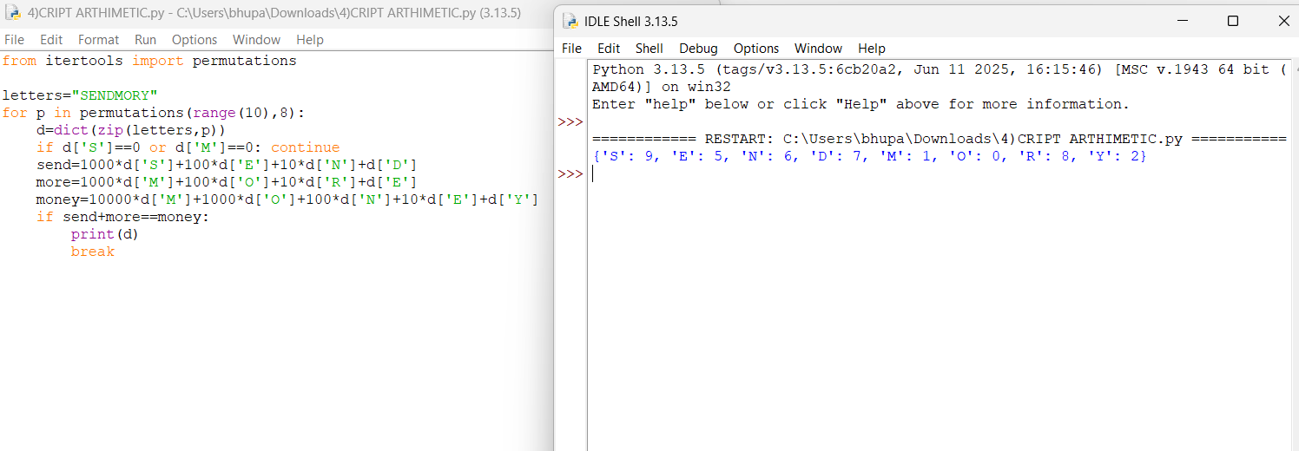
Result:
The cryptarithmetic puzzle was solved successfully.

